**These are the notes referred to on the following official copy**

Title Number MX352603

The electronic official copy of the document follows this message. This copy may not be the same size as the original.

Please note that this is the only official copy we will issue. We will not issue a paper official copy.

**1**

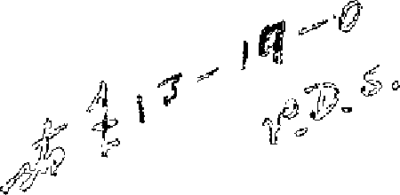

THIS LE.11SE made the

day of'

*i*

*rtc - Afo.<:k/* -

Che tb0usand nine hundred and f'ifty <if":&-..,,.,.

## BETWEEN

DAVIS OCNTRf,CTOl:tS LIMITED whose registered office is situate at 352 Kilburn High Road in the Ooun ty of London (hereinafter ce lltid "the Lessor" which expression shall where the context so permits include the persons for the time being entitled to the reversion

immediately expectant on the determination of the term hereby

.._·r:. -=.] 1 t{,._,!-t .; il\".'·r- --,-_. tit:_- ---

createa) of the first part Cons kiJ.0(:', :: iy ::·..,,.11.:.: \:"iJ1 pj' }4 *1* :c,i;Jt

*,1*-,,



(hereinafter called nthe r-essee11 which expression shaJ.l where the context so permits include the persons deriving title under the Lessee) of the second part and FLATS *Jil-1)* EST.ATES lfl,!Tl:,GEMENT LD.ITTED whose registered office is situate at 159 Victoria Street in the City' of Westminster S. W. l (hereinafter called "the Companyu) of

the thira part

N OW THIS LEASE made in oonsiaeration of tbe sum of TVi/0

Term

# Rent

THOUSll!-Tf) FIVE H1:rNDRED 1.ND FIFT'I'.' POUJ\l!)S paid by the Lessee tc, the Lessor ( the receipt whereof the Lessor hereby acknowledges) and of the yearly rent and covenants on the part of the Lessee

· hereinafter reserved ana contained

W I T N E S S E T H as .follows:-

1, THE Lessor HEREBY DEMISES unto the Lessee l,I,L TH.AT Flat

**Panee**  all end stazrcase,aescribed in Part I of the Schedule hereto (hereinafter together called "the Flat") TOGETHER 'WITH the rights privileges and appurtenances set out in Part II of the Schedule hereto EXCEPT *1.ND* RESERVING to the Lessor the **rights** set out in Part **IIf** of the Schedule heretn

TO HOLD the s.ame unto the Lessee frQm the 25th dsy of March 1957

for the term of 1\1INETY NINE YEARS

YIELDING- AND PATIN therefor during the seia term the yearly

1

,.

LESSEE'S

C!OVEN.t\NTS

To pay rent

Ti:- pay rates

anrl taxes

To repai:r-

## Exterior

painting

Interior

## painting

rent of TEN pOJ TT)S payable by fnur equal in talmcnts in advance on the usual quarter clays in cecd and every year free of any deduction whatsoever except the Landlorr1s Property 'l'ax The first such payment or a proportionate part thereof to be made on the execution hereof

, THE LESSEE HEREBY." COVF,JITJ.}lTS with the Lessor as follows:-

(1) To pay the rent hereby reserved at the time and in manner aforesaid without any aeductir:m except as aforesaid

. (2) To pay and discharge all rates taxes duties assessments charges and outgoings whatsnever whether Parliamentary parochial or of any other description which now **m·re** or during the term h€reby granted shall be imposed or charged on the Flat or any part thereof or the T,essor or the Lessee or the owner or occupier **in** respect thereof ( the I,andlords Property Tax only excepted)

1. Wrom time tn time and at all times during the said term well eind SIJ )stantially to rep;,iir uphold support clean maintain

drain ana keep the Flat,iue-;l, S.-ag.-t!-& ):l;t.;i:: r.,.-b.a.ll-.t'.;.e:i::i:;:o.f:_b.u:t and **also** and **landingjthereto**

**e,,ee, i-R-** the s-ta ire a se/lead rni'{;.r;:.f4A- <::'.i.-e"'-t·. -:a.c -4all) ?-nd a11

seditions which may at any time during the said term be made to the Fla·t and the fixtures therein AND jcintly w:i th tbc Lessee or

T,essees f'r,r the time being of' other flats entitled to use the same tn repair maintain ana keep the party vralls hatched black on the Plan annexed hereto

1. In the yee,r One thousand nine hunr3rea a.nd sixty anti

thereafter once in every third year nd in tbe last year uf the said term whenever ana however determined tr, paint in a ooluur to be approve<'! by the 1,essor' s surveyor for the time being all the riu tsiae wooa and ir0ri.work of the Flat and all additions theretr.i with two coats et leest of good c•il anc1 white lead paint in e proper and workman like mann r

1. Once in every seventh year and in the last year of the

*I*

2 /

..

,,

said term whenever and however determined to paint all the

### and also the stairoese and landing leading thereto

interior o the **Flat/ @ 4 8&- -e -g Qa )** and all additions thereto usual or proper to be paintea wi h two coats

at least of gnod oil and white lean paint in a proper and workman­

like manner and also at such times as last aforesaid to whitewash

### . and the said staircase and landing leedin

c0lour and paper such portion *nr* tbe interior·of tbe Flat/as are **thereto**

usually so treated.

Joint liability f'or hall

To yield Up in repair

Inspectinn

by Lessor

1. Proviaed always and it is hereby declared that the liability of the Lessee under the covenants contained in sub­

clauses (3) (4) ana (5) hereof shall so fBr as relates *to* the

**landing and edged red and the staircase leading thereto eR ¥& ee-k&** colourea yellow/on the plar/bc a liability jointly

with the lessee for the time being of the adjoining Flat Number ***A* 7 in** the Building and shall so far as relates as aforesaid be enforceable as 1.f such covenants baa been enti;:•r d into by th,-.{'

Lessee jointly -with such other lessee

1. To yield up the Flat at the expiry or sooner determination of the said term in such state of repair decoration and condition as accords with the covenants hereinbefore contained together with all additions and improvements made thereto in the meantime and all fixtures of every kind in or upon the Flat or which during the said term may be affixed or fastened to or upon the same (except tenants fixtures)
2. To permit the Lessor and its rurveyor or agent with or without workmen or others at all reasonable.times during the saia term to enter into and upon the Flat or any part thereof

**-s-t&;i-N!®-s-e,** toview the condition thereof' and also effectually and substantially to make good and restore all defects and wants or reparation which shall be discovered on any such examination and of which notice in writing shall be given_by the Lessor to the I,essee'.Withip. one calendar month after the giving

or such notice

Repair by

## Lessor

Entry by adjoining Lessees

1. To permit the T essor if the Lessee sha11 make default in

any of the covenants hereinbefo.re containea for or relating to

### or of the said staircase and landing

the repair of the Ti1la **ti** (but without prejudice to the right of

### . staircase and landing

re-entry hereinafter contained) to enter upon the Flayand repair

the same at the expense of the I,essee in accc1raance with the covenants and provisions of these presents and tho expenses of such repairs or in the case of repairs for which the Lessee is

* liable jointly- with another or others. the app'.ropria te proportion of such expenses to be determined by the Lessorts surveyor shall be repaid by the :-essee to the T,essor on demand

1. To fE rmit the Lessor and the tenants of' the adjoining

**11t**

flats numbers *i* 6 and 7 ana their respective agents or workmen at

any time or times during the said term but only ,(save in case of urgency) at .reasonable h urs. and upon giving reasonable notice to enter upon the Flat so far as may be necessary for executing repairs or alterations of or upon such adjoining premises or for

constructing laying do·wn altering repairing cleansing emptying or maintaining any sewers watercourses cesspools gutters drains watet-pipes electric wires or gas pipes in connection with or for the accommodation of tpe said adjoining flats causing as little damage or disturbance as may be to the Flat and restoring the same and the surface of the soil and everything erected thereon to its form.er condition without any unreasonable delay but

without making any compensation for any temporary aamage or*[*

.,.-d

Insurance Premium

inconvenience

1. Not to do or suffer anything which will or may make void or voidable any policy for the insurance against fire of the Flat or of any adjoining flat or which causes an increased premium to be payable for such insurance

Not to assign (12) Not to assign charge underlet or part with possession

*I*

etc. tart only I

of part only of the Flat or permit or suffer any person to *!*

*/*

4

To register assignmen ta etc.

(13) Not to assign or trensfer the demised premtses except **to**

**an** assignee who shall contemporaneously with such assignment or transfer enter into covenants with the Lessor and the Compan'y in

,

a form to be approved by the solicitors for the time being of the Lessor to observe and perform the covenants contained in Clause 3 hereof and within twenty one days a ter the date of any assignment underlease or other devolutio of the demised premises at.his own cost to deliver to the Lessor's s_olioitors for the time being an abstract from such assignment underlease or other document contain­ ing the date thereof the names and descriptions of the parties thereto and speoif'ying the party or parties in whom the or any legal estate is thereby vested and will at any time pay to such Solicitors·a fee of one guinea in r spect of every suoh dealing

## To register assignments etc

assign charge unaerlet or.part with possession of part only of

the Ji'la t



Uae only as . (14) To use ana occupy the Flat a a private dweliinghouse in

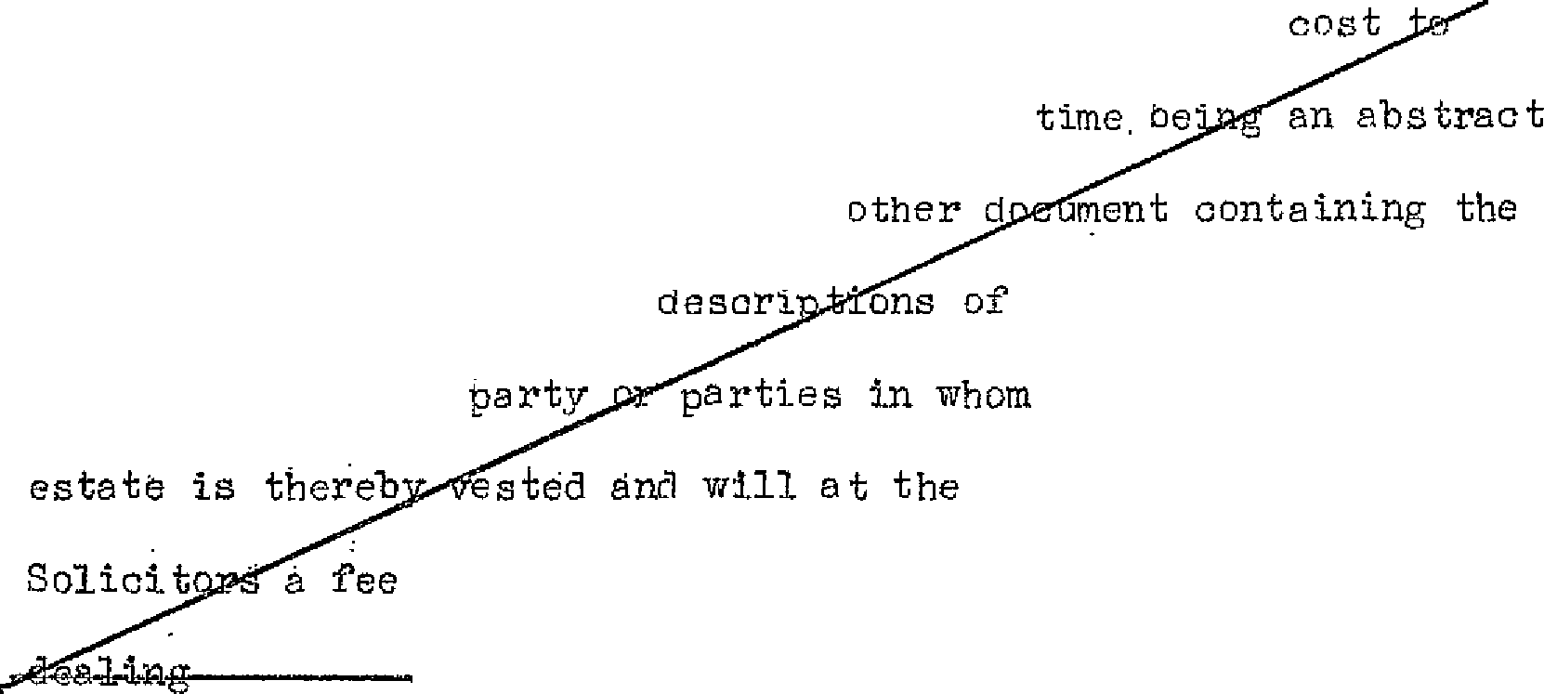

underlease or other devolution of the Flat at his own del.iver to the Lessor's Solicitors for the

from such assignment unaerlease or

date the ebf the names and

and specifying the

the parties thereto

any legal

same time pay to its

of Twenty one sbiilings ih respect bf every such

one dwelling-

house one sing'te or family occupation only and not for any other purpose

Not to (15) Not to do 6:r omit or permit to be a.one or omitted· anything

# contravene

Town Planning in the Flat the aoing or omission of which shall be a· cont avention Acts

. Not to cut

maim or injure

}Tot to make

alterations

To insure

of the Town & Country Planning Act 1947 ana to indemnify the

Lessor against all actions. proceeai'ngs damages penal ties costs

charges claims and demands in respect of such acts or omissions

1. Not to cut m8im or injure any·of the principal timQers roof's or walls of t-he Flat nor erect or suffer to be erected any new buildings thereon or make any structural alteration or addition to the Flat
2. Not to erect upon any pert of the Flat any building whether temporary or permanent other than the Flat hereby demised and not without the previous licence in writing of the Lessor or its surveyor for the t.ime being to make any alteration in the plan or elevation of the said· Flat or in any of the party walls or in any of the principal or bearing walls floors or timbers
3. At all tim3s during the term hereby granted to insure

a. nd keep.ti insurea the demised premises unaer a householders comprehensive policy for private awellin s (all items with no

5

exclusions) to be issued in the joint names of tho Lessor and the

.

Lessee by the Sun Insurance Office of 307 Finchley Ro2d in the

County of London or such other insurance office in the

### Kingdom

**United**

**-Ga-lPR-1;:r-**

as may from time to time be nominated by the Lessor in the sum of £2550 or such other sum as· the Lessor shall from time to time declare to be equal to the full value tber.oof (including

professional fees incurred in reinstatement) and to pay all premiums necessary for that purpose within seven days after the same shall become aue and whenever required to produce to the Lessor the

policy of such insurance ana in case of any damage or destruction

to the demised premises forthwith to lay out the insurance money in reb ilding or making gooa the damage sustained in accordance with any statutory or local enactments for the time being in force ana to make up any deficiency out of his ovm money PROVIDED i.LWKYS that if the demised premises shall not be kept insured as aforesaid the Lessor may insure tbe same and pay the premiums and the amounts thereof shall be repaid by the Lessee forthwith and until payment thereof shall be recoverable by distress as for rent in arrear

To pay Gas (19) To pay all charges for gas md electricity supplied to the and Electri-

city Flat as shown by separate meters affixed therein ana the charges

for such meter-s ana to ina.emnify t?e Lessor in respect thereof

To **o'ltserve**

-qegulations

(20) To observe ana perform the regulations ·set out in Part IV of the Schedule hereto and such other reasonable regulations which the J,essor -may from time to time make for the proper management

as a high-class resiaential btiilaing of the building of which the Flat forms part

To pay costs (21) To pay to the Lessor all expenses (incluaing Solicitors1

of' Section

146 Notice costs and Surveyors' fees) incurred by the Lessor inc_idental to

the preparation ana sel'."Vioe of' a notice under Section 146 of the Law of Property Act 1925 notwithstanding that forfeiture is avoided otherwise than br relief granted by the Court

6,

;-

### X and in insuring in the joint names of the Lessor and.Company against Third Party claims made against them or either of them in respect of the lawns gardens footpaths and carriageway

Lessee's covenant as to garden

etc.

Company's covenant as to garden

# etc.

LESSOR'S CO TE'.N"ANTS

## Quiet

enjoyment

liepair ana Insurance of adjoining premises

1. THE LESSEE Iill'REBY COVEN.tiNtrs with the Lessor and as a separate

**in the year 19.57 the** sum **of £10 and**

covenant with the rJotnpariy to pay to the Compan:/ in each •

### succeeding year a

/sum equal tn one twelfth of the aggregate of FIRST all expenditure

reasonably and prope3:ly incllrred by the Company during the

previous calendar year in performing the covenants on th1part of

**X**

the Company set forth in the succeeding clause hereof and SECOOD an amount equal to Ten pe cent of such expenditure such amount being payable to the Company as a management fee such sum to be paid to fue Company wi tl1in one month after a demand in writing therefor has been left at or sent by post to the Flat addressed to "the Lessee" thereof

1. THE 0CMPJI.NY H:F.1IBBY OOVENJJITTS wi tb the Lessee that the Lessee duly paying to the Company tbe mmeys payable under the last fore­ going clause hereof the Company at all t:i.mes during the term hereby

granted will maintain and keep in good orner repair and condition

'.:. *,,:,:_*:,; '

as a lawn or garden the lnnd coloured green on the,,.,plan and will

repair maintain and clean the fnotpaths and tbe carriageway coloured yellow on the plan

1. *TEE* LESSOR HETIEBY COVENJ,NTS with the Lessee B.s follows:-
   1. That the Lessee paying tho said yearly rent hereby reserved

and observing and performing the covenants and con<litions on the part of the Lessee herein contained shall andmay peaceably and quietly possess and enjoy the aemised premises during the term hereby granted without any lawf'ul interruption or disturbance by the Lessor or any person claiming under the Lessor

* 1. That the Lessor will not during the term hereby gran tea

### below

grant any lease or tenancy of the premises immediately **& e** the

## ' 6

Flat ana lmown as Flat No. ***1*** save upon terms that the lessee or

tenant tr ere of cmrenants for the repair of the said Flat i\fo. ***1* 6**

. **below**(including the level of the underside of the

everything **&Q 0**

### which forms the floor *ot* the flat hereby demised

concrete floor **9 - - --'Z-s.wJ.- l,l,a,i-l:i.. -i -**

7

ADDITION CLAUSES TO BE ADDED TO LEASE

No. 7 {to be annexed to Schedule Part 2). The right in common with all others for the time being having the like right for placing and using a refuse bin in the refuse binEfiolosure forming part of the ground floor Flat No.

No. 11 (to be annexed to Schedule Part 4). Not to fix a wireless or television aerial to the exterior of the said flat or building but shall be entitled to us such television aerial as the lessors may

erect on the roof of the said building, the position of such aerial to be at the absolute discretion of the lessor.

*r*

ADDI'.CIO:i:1 cuusgs *TO* BE ADDBD TO IE.ASE

?i!o., *7* {to be annexed to Schedulo. Part 2}• The right it1 eomraon \"d th. all. other·s f'o:r: .the .1.;imo beili.g havi..Vlg the like righ'f; for J>lacing and iisi11g a refuse bin. in ·che refuse bill. e.rlc1=osure fo1111ing part •O:f "abe ground floor Flat Ho.

Ho... ll. (to be annexed to- Schedule Part 4},_, lifot to fix e i-Ji.reless or television aer-.tal to th.e extp,rior or tho said £lat O.+' bui:td bu"l; shall be entitl.ed to us such t&levi.s.ion aeria-1 os the lessors rnay •

erect oa the :coo:£ of the ·said •building,, the position of such aerial to be a-t the absolute discretion o£ the lessor. •

To permit Company to enter garoen etc.

Pl:'oviso for

re-entry

Service of Notioes

**tl,e- - s &)** in the like terms as·arc set out in Clause 2.(3)

6

hereof and to insure the saia Flat No. ***1*** in the like terms as a e

set our in Olause 2, (18) hereof PROVIDED *M}i{AYS* and it is hereby agreea that in the event of the assignment by the Lessor of the reversion irrmediately expectant upon the determination *bf* the term hereby granted the Lessor shall on and from the date *cf* such assignment cease to be liable in respect of any breach or.breeches of this covenant which may occur after the date of such assignment,

* 1. That the Lessee duly paying the monies payable unaer Clause

3 hereof' tbe Lessor will permit the Company its servants and agents to have access to the land col0ured yellow on the plan for the

1

purpose of performing the covenant on the part of the Company

con ta inea in 01a use 4 hereof

6 PROVIDED 1\LVvllYS that if the saia yearly rent hereby reserved or any part thereof shall at any time be unpaid for twenty one days after the same shal1. have become aue whether the same shall 'have been legally demrmaea er not or in case 0f the breach non­ performance or non-observance of any of tho covenants on the part of the Lessee herein containe:!'then and in any such case it shall be lawful for the Lessor or any person authorised by it to enter into and upon the demised premises or any part thereof in the name of the whole and to repossess the same as of its former estate and thereupon the term hereby created shall absolutely determine but without prejudice to any right of action or remedy c,f the LessD'r **in** respect of any breach of any of the covenants by tbe Lessee

bereinbefore containea

' ,.,

'" '·•;•·., ,

rt''"-'-=-41:.:::,_•l-

7. IT IS :HEREBY AGREED that any notice hereby regcdred or authorised to be given to the Lessor or the Lessee shall be in writing and may be gi:ven in manner provided by Section_ 196" of the Law of Property

.Act 19·25 with respect tci notices to be given to a lessor or lessee under that *Act*

8

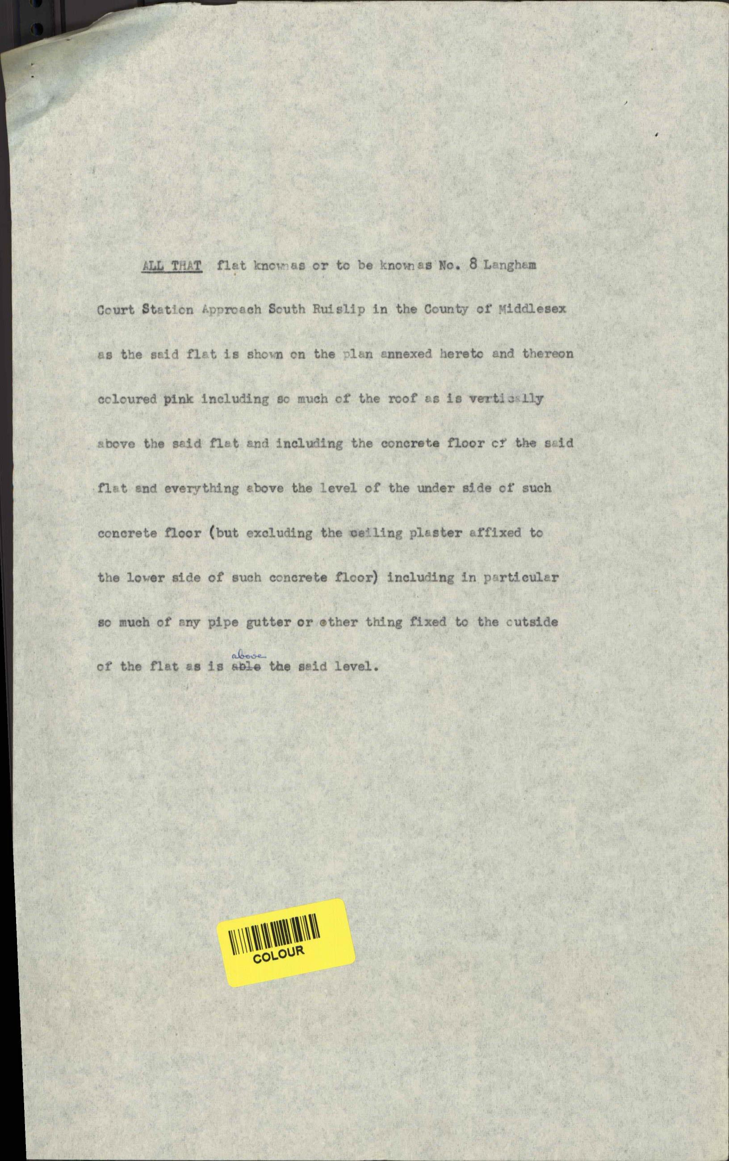

Constr1.1ction

M'arginal

Notes

Certificate a-s to value

8,, IT IS HEREBY hGREED that in this lease references to any ict

or /lets of Parliament shall be construed as including references to any statutory modification or re-enactment thereof for the time

being **in** force

1. TEE marginal notes shall.be deemed not tn·form part of these presents and shall not be taken into account in the construction or interpretation of' any cc,venant crnc1 i tion nr proviso herein c0ntainod
2. IT IS BEREB CERTIFIBD that the transaction hereby effected aoes not f rm part of a larger transaction or of a series of

tr ns.ac tioµ in respect of which the amount or va·lue or the aggregate amount or value of the consideration other than the rent exceeds - pounds

I N w· T TN E S S whereof the Lessor and the Co pany

bave hereunto affixed their CO\nffiOn Seals and the Lessee b0s hereunto

set his hana ana seal the day and year first before.written

SCH E. DUL E

P./\RT I

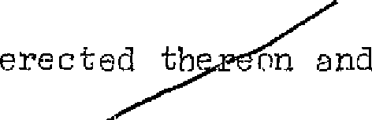:URST ATJ, THfl!L' piece--o.U..-a--E.-El. el pi:nk on Lhe pla_n.annexed hereto together with the Fl.at erected

knmm or to be knr-vim as No. 5 Langham Co·sztatriot Ruislip in the ODunty of Midalesex *liND*

Lpproach South

SECONDLY i'>LL THAT piece of land co7 yellow on the said plan together with tbe entrance hal staircase erected thereon and adjoining the said Flat whid aid Flat entrance hall and staircase

*r*

_shall be deemed the foundations thereof and to extend

upwards to /level of the underside of,·the_ concrete ,floor formi i e'first floo f the building and shall be deemed to be-.pJ,a.s.t.@-P--GQ-,H-¼ the:l:a L au1..1-uf'"· the en trance hall

9

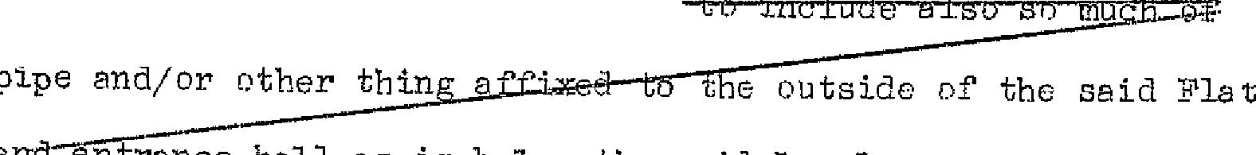

af'fi=x:cd to □i.,ch ecmer e-te- f1:r,-ct.t-and

-any

- and @t1.t:r:nl:oe hall es is l;i@low tho s:i;dd lt..ireJ

Rights incluaed in aemise

# Easements

of .Access

Easements

of Water etc.

. Support and

Protection

Lawns and Gardens

.Access to adjoining Flat

Benefit of

1:teil,"Ula tions

## S O R E D U L E

PLR1' II

1. The right in common witb the Lessor and the lessees or occupi.ers for the time being of the other Flats in tbe Building ana all others

having the like right to use for purposes of access to and egress

**first**

from the Flat/the service roaa 8na paths colourea yellow on the

### and second the lending end staircase leading thereto from the said lan/s - - ..i;;. ts- Q -th@- Q i-lllAiQ eoaoc ground floor

**c£-ilbe. d i a..1:Qad..AUd-Pat a-h eioeet# Pe- eR 4 0**

1. The right in common with.all otbe s for the time being having the·like right of passage and running of gas electricity water and soil from and to the Flat thrr:iugh the pipes wires conduits and

drains in under or upon the Building

1. .l\11 such rights of support and protection as are enjoyed by the Flat from the other flats adjoining the same at the date hereof

4•. The right to use in common with the Lessor and the lessees or

occupiers for the time being of other·flats in the Building and their visitors the lawns· ana gardens c.oloured green on the plan subject to such reasonable rules and regulations for the common enjoyment thereof as the Lessor may f'rom time to time prescribe

1. The right (to be exercised save in a case of urgency only at re8sonable times ana upon being given reasonable notice) to

ent upon the premises aajoining tho Flat ana in particular upon

# 6

the f'lat known as fio. ***/1*** for the purpose only of executing any

necessary repairs and alterations to the demised premises the

Tessee causing as little damage disturbance and inconvenience

as possible and making good all damage occosionea thereby **but without making eny compensation for any temporary damage or inconvenience**

1. The benefit (in so far as the Lessor can grant the same) in

10

'"

*)*

common with tbe Lessor and other persons enti tlccl thereto uf any covenant or agreement entered into by a lessee of any-other flat in the Building with the Lessor for the observance and performance

of the regulations specified in tbe Scheaule hereto

SCHEDULE

PllRT III

"Right to pass along-Entrance Rall and Staircase

EXGEPTI ONS *J,ND* HESERVflTI CNS

1. The right for the Lessor ad the lessees and pcoupiers of the adjoining flats Nos. 6 7 and 8-to pass and re-pass over and along the said entrance hall and the 'staircase leading therefrom for the

purpose only 0f access tn or e_ress from the said entrance hall and staircase or f'or the maintenan e repair or al tera tiPn of the said flats nr any of them

Support and

Protection

Passage· of Water etc.

Access for adjoining Lessees

Rights of

## Light

* 1. **j,.** Such rights of s1Jpport and protection to tht flats adjoining the Flat as are now enjoyed from the Flat
  2. **/.** The free and 1Jninto_rrllpted passage and running· of WEI tGr and soil gas ana electricity from and tn the other flats in the Building thr0ugh the pipes wires ccmdui ts and drains in_ under or 1Jpon the Flat
  3. **J.** The right for the Lessor and the lessees and occupiers of the.

**1'1"**

adjoining flats J\;os. ***/4*** 6 and 7 to enter upon thE Plat or any part

thereof b!Jt only (save in case of urgency) at reas0nable times and upon giving reasonable notice for any of the purpos.cs and subject to the provisions mentioned in Cla!Jse 5 of Part II of this Schedule

* 1. **i.** The right f'or the Lessor at any time hereafter to build or

### (other than the land coloured green and

rebuilcl on any adjoining or neir-hbnuring lana/ according ti:, such **yellow on the**

### plan)

plans (whether as to height extent-or otherwise) and in such manner as the Lessor shall think fit notwithstanding any inter­ ference thereby occasioned to the access ef light to the Flat

SCHEDULE

?J'.RT IV

REGULLTI CNS



part thereof **...1l,,@,'i- -t.1::..in.g** which shall or may be or "become a nuisance damage- annoyance or inconvenience to tho LessQr or to the lessee or occupier for the ti'Ile being of any ad joining or neigh­ bouring flat or to the neighbourhood)

1. No person *of* Uhsound mind or of drunken or immornl habits

shall be permitted to resicle in the Fle t

1. No windows or lights belonging to tho Flat or the Building of which the Flat forms part shall be stopped up darkened or obstructed
2. No music or singing whether by instruments voices wireless gramophone television or other ttie1:ms shall be allowed in the Flat or the Building between 11 p.m. and 7 a m.
3. Nothing shall be deposited or left in the entrance hall stairways or passages of the Building neithcr shall any carpet mat or rug be beaten or children allowed to play therein neither shall the same be in any way obstructed
4. No person shall reside in the Flat unless the floor thereof (including the passages) are covered with linoleum carpet rugs

or other-suitable materi9J.s except while the same shall be removed for cleaning repairing or decorating the lat or for some temporary purpose (This "Regulation howevar nr.,t tP apply to a ground floor flat)

1. No flower pots or other things shall be placed outside the

winaows of the Flat unless securely fastened t[l the window boxes **r,:-o ed**

to the satisfaction of the Lessor

1. Not to use or permit or suffer to be used the land coloured green on the plan otherwise than as a lawn or garden and not to

If .,,

do or permit or suffer to be done thereon anything which would be a nuisance or inconvenience or disturbance· to any other person using the saire

* 1. J\To advertisement or not:i.ce of eny description shall be placed

on tbe outside of any of the walls or doors of the Flat.or the Building except th.at tho name of the Lessee (without any notice of the profession or business of the· Lessee) llUJY be painted er

affixed outside the entrance door of the lat in such style as the

Iessor shall approve

* 1. Not to leave or park any motor or other vehicle in tbe

carriageway adjoining the rear 0f the Building sn as to cause

### the Lessor or

annoyance or inconvenience to/any lessee **or occupier of any**

### flat in the building

- . ,

**f**

**hi ft.ta:bl. 6a¼fmtt!7** sf:.c il hola- tho u:.:J.:iocc. 1. ;-;; :ir.: ,=·rJ 



**Untll** •-•·**•r , otlyeam \***

--- *--- :_ ·;1 3/'-=*;f ..

**the u ath** iJ:i..' **tho aur'f"i\,llttt** :

- Qi;.·t 1***-***0***i "4.a.***,a:G:-&.i:r i¥'"Jl·•i h;:; ; l't b j:)c.iii ;)f. ·ii tHVO ,;,- ::! i1--i L0 -tir;i('"'·- ;;.I

bei:1;s o:C· ·thzi 'Gaicl. '£..ll')..T .-XpeG h:111 £1::'v .. 1)0\:·. t? to:,m:;7i.iUnts ·

***h;*** 1,- *·:':'<r.* **u,** /i,=. tc "l ,:,; •; ;", 7l f)')!1'1nl \·;•i ,t:! ;] **•i.<:,***,.Jf"J,'* ·,--; ,..,.;, ·:-1,,..., I':':,;.,/} •

**.,1._J.,,..i.-.it;;,I(.,, j.:¥._"-'-P** .,_, • **W** ..,_,_ ......, ***A* .-o:_-.1** ""'

I

I

_,; ,; **0,lw.'w)'** -- .. **l:i-;,,i, .· )i,,_,.t_:/ ......,u, : }J}..:\• J r o**

trltl: .'.ll. th ])Ot:c:? *EJ .·* c ·, 0-:t-,tnlu·t:.::, ,J,?t}Cj/•

-=----. - -- --- ..·- --

13

,.

..

FL.AT 8

•

DATED  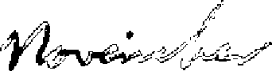 195

DAVIS CONTRLCTORS LITuIT'.l.'ND

and

FLI,TS & ESTJ,TES Mt.NJiGEMENT LTI'IIITED

to

LEllSE

of'

Flat No. *J',* Langham CPurt, Station Approffch, South Ruislip in the Crv•1.ty of Middlesex

Term: 99 years

From: day of

Rent: £10-0-0 per annum

195

  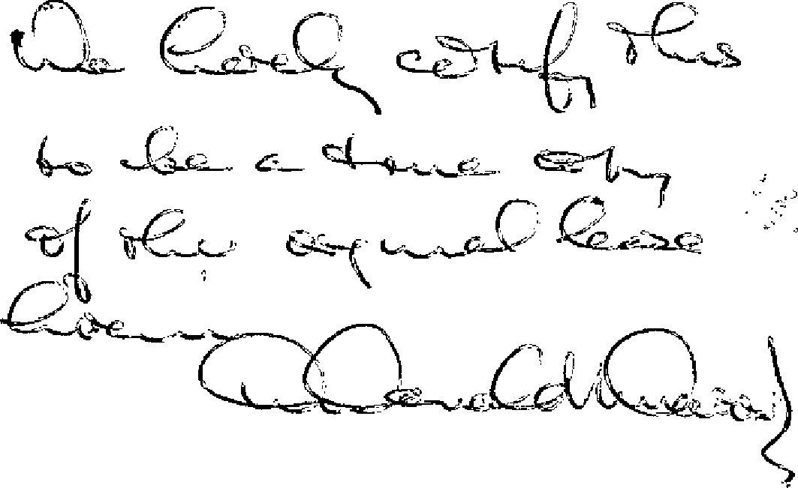

D. Donald L. D)vies & Co. ,

195 Ealing °RDad,

Llperton,

Wembley,

Middlesex.

